Objective: Manas, your AI knowledge and skills are on full display! I absolutely love your video demonstrations because they are educational and insightful. I always look forward to seeing your deliverables.
This week, we will translate our extraction and conversion tool into a functional, interfacing local LLM. This proof of concept is essential for the grant I will write. If all works as planned, we will finalize this preliminary artifact development and prove its functionality by loading the extracted text stored in chunks into AnythingLLM. Thus, our final step is “Reuse” as shown in the workflow diagram.
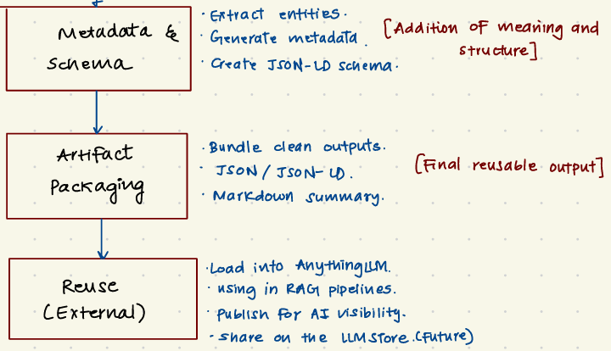
Deliverables: By Saturday, 2/14/2026, please email the following:
- Video demonstration of the vector embeddings loaded into AnythingLLM (or similar) and used to contextualize responses in a Q&A query.
Instructions: I have found an interesting angle to use as positioning our artifact. I will pitch to my business school colleagues the novel application of our local files-to-personalized LLM in the context of conversational commerce. For instance, OpenAI announced that it will include ads in its conversations (Our approach to advertising and expanding access to ChatGPT | OpenAI). Yet, they claim they will not use personal information to provide targeted ads. The benefit of a personal LLM is that we can create a permissioned personalized layer that will allow an agent or LLM to access (with permission) to provide personalized responses. That is, the agent can retrieve personal attributes, preferences, psychographics, demographics, and more from the personal LLM and use to provide tailored, personalized responses to the user. In the future, when users deploy agentic AI to purchase groceries, plan trips, pay bills, etc., on their behalf, the permissioned personalized layer we create can be used to enhance the decision quality and outcomes of these transactions.
I will continue to flesh out the business use case. With your expert dev skills, we will surely develop a viable tool that is funded through either Kelley or a science grant. More excitedly, we can create something to commercialize, hehe.
Thanks for all you do, sir!
Have a great week ahead and enjoy Super Bowl Sunday, my friend.
Respectfully,
Nick

